28th Solar Keymark Network meeting  Draft agenda (R0)_2020-01-14 Mailing date_ VD/AB  Meeting time:  Tuesday, March 10th, 2020, 13:30 - 18:00  Wednesday, March 11th, 2020, 09:00 - 13:00  Meeting location:  Hotel Laico Spa & Conference Center Tunis  Avenue Mohamed V, Place Des Droits de l’Homme Tunis  Tunisia  website: laicotunis.com-tunisia.com/en/  Contact person for the supporting programme:  Ms Verena Stauber, verena.stauber@ptb.de  Deadline for proposals for decisions and resolutions or any item to be added in the agenda: February 18th, 2020  Web conference login: to come | 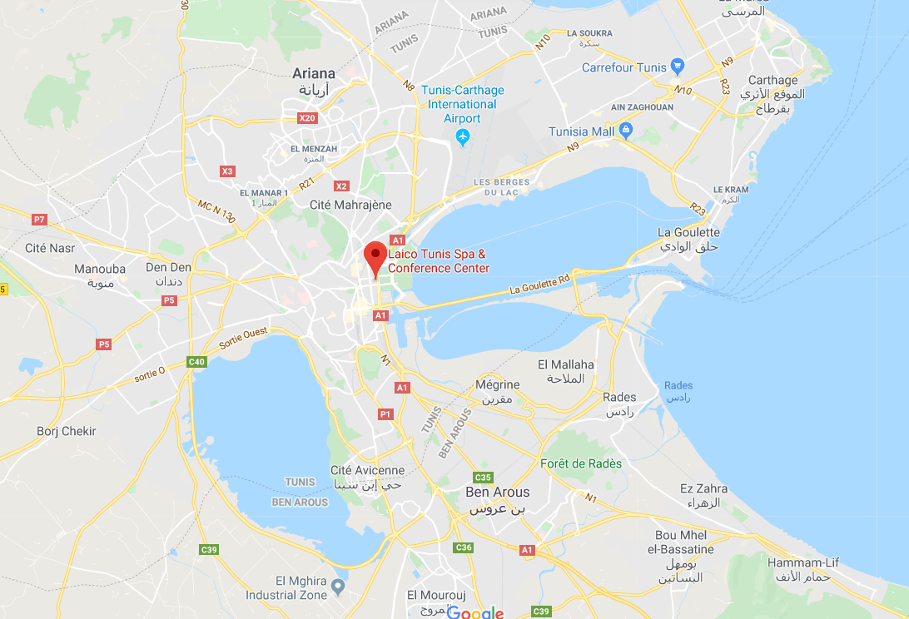
Related meetings at same place (see supplementary document “2020-01-14_SKN et al 2020_programme draft.pdf”)
- Day for the Tunisian Industry and laboratories
- Joint technical meeting of CENT/TC 312/WG 1 & ISO/TC 180/WG 4
- Exchange meeting: experiences with Solar Keymark video inspections
- Plenary meeting of CEN/TC 312
- Meeting of GSCN
- Joint meeting of GSCN & SHAMCI
- Meetign of SHAMCI
On-line registration - here - Registration deadline: February 18th, 2020
Note: If the above on-line registration form does not work for you, please e-mail to Vassiliki Drosou at drosou@cres.gr
To simplify the organisation and to guarantee a smooth meeting please be kindly reminded that according to SKN_N0102R19:

- Proposals for resolutions shall include a proposal on how to include / implement the resolution in the related document. Proposals for resolutions shall be sent to the SKN Manager at least 3 weeks before the meeting.
- All input to the draft agenda (proposals for decisions and resolutions or any item to be added) should be sent to SKN Manager at least 3 weeks before the meeting by email. The SKN Manager shall circulate the final draft agenda 2 weeks before the meeting.
- "Resolutions" are decisions about changes in the SKN Internal Regulations or in the SK Scheme Rules and its Annexes
- All other decision are called decisions
- For any decision, a simple majority of all the voters plus a simple majority of the peer groups (50 % majority within peer group) is required. Changing the SK Internal Regulations requires a positive vote of a 2/3 majority of all the voters and in all peer groups a positive vote of a 2/3 majority of the peer groups. Proposals for changing the SK Scheme Rules require a 2/3 majority of all voters. In all other issues of the agenda, a simple majority of the votes is necessary to make a decision.
A 2/3 majority of any peer group can claim to postpone a decision to the next SN meeting.
A 2/3 majority of the votes of a peer group can veto a decision. Abstentions are not counted.
- For the following entities the participation in the SKN Meetings is mandatory.
─ Solar KEYMARK empowered certification bodies (organization)
─ Solar KEYMARK recognized testing laboratories and inspection bodies (organization)
─ SKN Chairman
─ SKN Manager
─ SCF Chairman (in case SCF topics are on the agenda)
─ Representative from SKN secretariat Solar KEYMARK Network

Tuesday, March 10th, 13:00
Item | Topic/content/responsible
 | Opening Ceremony
1 | Opening of the meeting /AB  Short welcome and practical information
2 | Introduction of participants /All  Excuses from:  Attending via web:
3 | Competition Law / PD
4 | Approval of the agenda /All  Test of SKN Voting Tool (In case that there is a problem with the voting tool/Internet, voting cards are prepared by the SKN management)  Voting only needed if requested by at least one participant with voting rights.
5 | Comments to the minutes of the 27th SKN meeting /VD
6 | Review of Decision list and votes by correspondence / VD
7 | Review on SKN WGs status /VD
8 | Absences from 27th meeting/VD
9 | Dates and places of next meeting(s) /AB/VD  - 29th meeting: 2020 - October 20th, 09:00 - 12:00 and October 21st , 09:00 - 12:00 Web Meeting  - 30th meeting: 2021 - March 9th, 13:00-18:00 and March 10th, 09:00 - 13:00 – Athens, Greece (hosted by EBHE)  - 31st meeting: 2021 - October 26th, 09:00 - 12:00 and October 27th , 09:00 - 12:00 Web Meeting  - 32nd meeting: 2022 – March 15th, 13:00-18:00 and March 16th, 09:00 - 13:00 –  Proposal for decision:  "The 32nd meeting: 2022 - March 15th, 13:00-18:00 and March 16th, 09:00 - 13:00, will be held in ….
10 | Funding of proposals from the 11th SCF call/ SCF steering group for SCF project applications (11th call) / H. Drück  Proposal for decision:  "The SCF applications recommend by the Solar Certification Fund Steering Group for funding as described in document "SKN_XXX", are accepted and the corresponding activities will be funded."
11 | Update on SK Scheme Rules
12 | Update on SKN task Force on taxation matters (M22.D10) / P. Dias
13 | Report from SK Database WG on Database and IT infrastructure / G.v. Amerongen, P. Dias
14 | Annex E revision / A. Bohren
15 | Update on energy labelling topics / P. Dias
16 | Experiences with Solar Keymark remote factory inspections inspections / U. Fritzsche
17 | ScenoCalc update / P. Ollas
18 | Report on Update on 10 % Rules WG /S. Fischer
19 | DST-SolTherm (SCF 0c03_1) project /G.v.Amerongen
20 | DST-Extension-Qnonsol (SCF 10C10 DST) project / G.v. Amerongen
21 | SK-Scope-vAc (SCF 9C02.1) project / G.v. Amerongen
22 | Proposal on refining definition of 10 years validity / KMO, EkTSUB
23 | ValiCol (SCF) project / S. Abrecht
24 | Certification issues related to exports / A. Kraidy, PD
25 | Proposal concerning how to handle standards transitions (ISO 9806:2017, EN 12976-1:2017 & EN 12976-2:2017) TÜV Nord Cyprus / G.Nikolaides
26 | WG on Elaboration of a procedure for issuing collector test reports based on transferring of data from existing test reports / S. Scholz
27 | Update on new/deleted labs/CBs
28 | Status of the PVT Working Group / U. Fritzsche
29 | Thermodynamic collectors / Follow up /S. Scholz
30 | ValiCol (SCF) project / S. Abrecht
31 | New Equivalent absorber coatings
32 | New Equivalent glazing
33 | New Equivalent insulation
34 | Report/update on “Inter-laboratory Comparison - ILC on Data Analysis”, SCF7 Project / AB
35 | Report on SHAMCI update / K. Salmi
36 | Update on energy labelling topics / PD
37 | Information from CEN Keymark Management Organization / K. Vehring
38 | Report from CB Working group / S. Scholz
39 | Update on complaints and Reports on misuse of Solar Keymark / S. Scholz
40 | Solar Certification Fund Projects – General Status Reports / L.Mico
41 | Update on Action Plan working groups:  - AP1 Strategy WG (?)  - AP2 Marketing and Communication /Pedro Dias  - AP3 Installers WG (K. Vehring) – on hold  AP6 Legal Requirements (G. v Amerongen)
42 | Update on Global Solar Certification Network / H. Drück
43 | Update on standardisations issues  CEN TC 312 / ISO TC 180 WG1 (VD)  CEN/TC 312/WG1 and ISO/TC 180/WG4 (AB  Updates from Liaison officers:  - S.Fischer (IEC/TC117):  - K.Kramer (IEC/TC82)  - J-M. Suter (TC164)  G.v.Amerongen (TC 228 and TC371)
44 | Update on solar heating and cooling market / PD
45 | Any other business
46 | End of meeting / AB

Meeting duration
1st day: 13:00 – 18:00 = 5 hours; one coffee break of 30min effective meeting time 4,5 hours
2nd day: 09:00 – 13:00 = 4 hours; one coffee break of 30min effective meeting time 3,5 hours
4,5 + 3,5 hours = 8 hours = 480 minutes effective meeting time
AB: Andreas Bohren, SPF, Chairman Solar Keymark Network, Andreas.Bohren@spf.ch
VD: Vassiliki Drosou, CRES, Manager of Solar Keymark Network, drosou@cres.gr
PD: Pedro Dias, ESTIF Secretary General, Administrative Secretary of Solar Keymark Network, pedro.dias@estif.org

