SOLAR KEYMARK Scheme Rules
SKN_N0444R2 / Edition 2019-11-25

www.solarkeymark.org

Table of Contents
0. Introductory note and fall back rule 3
1. Abbreviations and definitions 4
2. Introduction to the SOLAR KEYMARK 5
2.1 Product main types covered by the scheme 5
2.2 Certificate holders 5
3. The SOLAR KEYMARK certification procedure 6
3.1 General 6
3.2 Random selection and submission of type test samples 6
3.3 Initial factory inspection 6
3.4 Third party initial type testing and periodic product surveillance 6
3.5 Specification of the manufacturer's application file 7
3.6 Certification 7
3.7 Product certification for OBLs and brand names 7
3.8 Obligations for license holders 7
3.9 The SOLAR KEYMARK Weather Database 8
4. Validity of the certificates 8
4.1 Temporal validity 8
4.2 Changes in products – re-testing 8
4.3 Changing CB, TL 8
5. Publicity 9
5.1 Languages 9
5.2 Display of certificates and data sheets 9
5.3 Labels and logo 9
6. The Fees 9
6.1 The KEYMARK licence fee 9
6.2 The SOLAR KEYMARK Fee 10
6.3 Collection of the fees 10
7. SOLAR KEYMARK certificates and sub-licenses for other brands, product names and resellers 11
7.1 Granting SOLAR KEYMARK certificates (option A, B, and C) 11
7.2 Maintaining SOLAR KEYMARK certificates (option A, B, and C) 12
7.3 Rules for withdrawal of certificates 13
8. The SOLAR KEYMARK complaint procedure 13
8.1 General procedure 13
8.2 Third party team 17
8.3 Special test 18
9. Requirements and obligations for CBs, TLs and IBs 18
10. Legal 19
10.1 European regulations 19
10.2 EU-GDPR 19
11. Annexes, Forms and Templates 20

Introductory note and fall back rule
These SK Scheme Rules (including the Annexes as listed in chapter 11) replace the version SKN_N0106R31 of March 2018 and the latest version SKN_N0444R1 of March 2019 of the SK Scheme Rules.
Existing certificates issued under previous versions of the Scheme Rules are basically not affected by the new Scheme Rules, however all new actions on certified products such as surveillance activities, modifications of the product, building families, adding OBL certificates, re-certification etc shall be conducted as defined in the new SK Scheme Rules.
If for any reason the revised Scheme Rules are not applicable or are deemed inappropriate in specific situations, the previous version of the SK Scheme Rules shall be consulted and applied in agreement with the responsible CB. The CBs, TLs or IBs are then obliged to inform the SK Management about such occurrences to propose appropriate modification of the Scheme Rules.
The version SKN_N0106R31 of March 2018 and all its Annexes are kept publicly available on the SKN Webpage.

Abbreviations and definitions
CB Certification Body
CB WG Working Group of all the Solar Keymark Certification Bodies
CC Complaint Committee
CCB CEN Certification Board
CEN European Committee for Standardization
CENELEC European Committee for Electrotechnical Standardization
CIR4 CEN/CENELEC Internal Regulations: Part 4 Certification (IR4): July 2018
CMC CEN Management Centre
EA European co-operation for Accreditation
FPC Factory Production Control
GDPR General Data Protection Regulation, (EU) 2016/679
IB Inspection Body
ISO International Organization for Standardization
IEC International Electrotechnical Commission
KMO Keymark Management Organization
NDA Non-Disclosure Agreement
OBL Own Brand Labeller
OEM Original Equipment Manufacturer
PI Physical Inspection
PSA Product Specific Annex
SCF Solar Certification Fund
SHE Solar Heat Europe
SK Solar Keymark
SKN Solar Keymark Network
SKNM Solar Keymark Network Meeting
TL Testing Laboratory
Certificate Holder: Company (legal entity with entry in the commercial register), which is responsible for fulfilment of all duties of the certification and has got the right to use the mark for the certified products. The certificate holder may or may not be the manufacturer of the certified product. In the case of not being the manufacturer, the responsibilities as licensee are the same as if it were a manufacturer
OEM: A company which supplies equipment to other companies to resell or incorporate that product under their own brand name is called Original Equipment Manufacturer (OEM). Some OEMs place their products on the market also under their own brand name. The term OEM includes this option.
OBL (sub-license, private label): A company which is placing OEM products on the market under its name or trade names is called Own Brand Labeller (OBL). OBLs don’t produce the products themselves. In this document the OBL is a company re-labelling a product with valid SK certification under his own company name and product name (brand) without making any other changes to that product, thereby taking responsibility for it as the legal manufacturer under the above definition, and thus applies for a SK certificate on his own.
Brand or Trade Mark: Brand is the name, term, design, symbol, or any other feature that identifies one seller's product distinct from those of other sellers. It is no legal entity with entry in the commercial register. A same product may be sold under different brands or trademark in different markets.

Introduction to the SOLAR KEYMARK
The Solar Keymark (SK) is a third party certification scheme based on the general CEN Keymark rules laid down in the CEN – CENELEC Internal Regulations Part 4 (CIR4). According to these regulations, the SK Scheme Rules are published as specific “Keymark-Scheme Rules” (Clause 5 of CIR4) and the Solar Keymark Network (SKN) is established as “Keymark Scheme Group” (Clause 6 of CIR4).
The SKN is a working group bringing together the interested and involved stakeholders and acts as an experience exchange circle of institutions active SK testing and certification. The SKN is responsible for developing and managing the SK scheme and is operating according to the SK Internal Regulations. The SK Scheme Rules are defining the specific requirements and working rules related to the CEN Keymark certification of solar thermal products. The SK Scheme Rules are managed by the SKN. Changes to the SK Scheme Rules and its Annexes must be approved by the SKN and by the CCB represented by KMO.
The SK Scheme Rules are defining the specific requirements and working rules related to the CEN Keymark certification of solar thermal products. They are kept as close as possible to the minimum requirements for Keymark Scheme Rules as given in 5.2 of CIR4. The SK Scheme Rules are managed by the SKN. All changes to the SK Scheme Rules including all Annexes must be approved by the SKN and by the CCB represented by KMO.
The valid version of the SK Scheme Rules including its annexes is always available at www.solarkeymark.org.

Product main types covered by the scheme
The scheme covers the following product main types within the work program of CEN/TC 312 "Thermal solar systems and components" always referring to the latest valid version:
- Solar thermal collectors as defined in EN 12975-1 and EN ISO 9806
- Factory made solar thermal systems as defined in EN 12976-1 and EN 12976-2
- Custom built systems as defined in EN 12977-1 and EN 12977-2
- Solar water heater stores as defined in EN 12977-3
- Solar combistores as defined in EN 12977-4
- Control equipment as defined in EN 12977-5
The scheme intrinsically refers to other CEN and ISO standards as referenced in the mains standards which are all available from the national standardization bodies (list of standards available see: standards.cen.eu). The certification procedure is always based on the version of the standards valid at the time of certification. The SKN defines transitional procedures for standards under revision (see PSAs) if necessary.
Similar products can be considered as product families. A product family consists of one or more products as defined in the product specific annexes (PSA) and in the standards. Every certificate covers only one product family.
The rules for building families are defined in the applicable standard and in the PSAs. The final decision on the possibility to unite different products into a family is taken by the CB.
A family is considered as one sub-type of one of the above listed main-types.

Certificate holders
The certificate is held by a certificate holder which can be a manufacturer or an OBL. Products can also be certified under different brands (Trade Marks) to be sold under different brands or trademark in different markets. The specific procedures and requirements for OEM/OBL are defined in Chapter 7.

The SOLAR KEYMARK certification procedure

General
To guarantee the constant quality level of the product, the certification scheme is based on the following four piles
- Random sampling of the products for type testing
- Third party initial type testing according to the applicable European standard
- Third party periodic surveillance of the manufacturers quality management system
- Third party periodic surveillance of the certified products

Random selection and submission of type test samples
The selection of products for initial type testing is made under the responsibility of the CB. The test samples for initial type testing are taken out of the current production or from stock of the manufacturer. Product specific details on the sampling procedures are defined in the PSAs. The inspector selects by random the test samples, marks them with a permanent mark (alternatively seals their packing) and either takes with him/her the test samples and delivers them to the TL, or instructs the manufacturer to deliver them to the TL. Sampled products should be marked and sealed such that they cannot be modified anymore before being delivered to the TL. Remote sampling procedures using video web tools or local representatives of internationally operating inspection companies can be used to reduce travelling expenses as long as all sampling requirements are fulfilled.

Initial factory inspection
With the initial inspection it is checked whether the manufacturing site fulfils the requirements stated in CIR4: The manufacturer shall operate a quality system covering the production line of the product for which the licence to use the Keymark is granted and which should be based on the quality standards which are at least of the level of the EN ISO 9000 series of standards. In granting the licence, the empowered CB shall take into account the existence of any quality system certificate issued by a CB that is accredited by a member of the European co-operation for Accreditation (EA).
The particular requirements regarding FPC are specified in Annex E.
The quality management system shall cover the production line. The findings shall be reported using the template in Annex A1. The factory inspection shall include the checking of the documentation of the related FPC at least once a year. In case the manufacturer is ISO 9001 certified by a certifier accredited by a national accreditation body being a member of IAF (International Accreditation Forum, www.iaf.nu ) the SK factory inspection is only required every second year provided the ISO 9001 certificate covering the certified product’s production is made available to the CB. For the initial certification none of the findings of the initial factory inspection shall be rated critical to the extent that conformity with the standard is endangered. Based on findings and conclusions of an inspection, interim inspections can be requested by the CB.
All OEM and OBL products covered by an inspection shall be listed in the inspection report to confirm the conformity of the FPC for those products.

Third party initial type testing and periodic product surveillance
The product to be certified shall be tested according to the applicable standard by a TL listed on the SKN website. The test reports including all referenced and sub-referenced test reports shall be submitted to the CB as a basis for certification.
The general product surveillance procedures are given in CIR4 and include product verification tests at least every second year as described below.
The certified products shall be tested for conformity to the product submitted for initial type testing on the basis of
- Technical drawings
- Materials and components specification files
- Visual inspection of products selected at random from production, from stock or from market.
The conformity check and all changes to the product shall be assessed on the basis of the rules defined in the product standards and the PSAs. The findings shall be reported using the templates in Annex A2. In case of deviations the CB decides either on corrective action to maintain conformity with the certified product or to modify the certificate based on partial or full retesting. If conformity cannot be re-established, the certificate shall be withdrawn by the CB.
All OEM and OBL products covered by initial type testing or product surveillance shall be listed in the inspection report to confirm the conformity for those products.

Specification of the manufacturer's application file
The applicant shall supply the CB with the information as required in the application form of the CB. This shall include at least
- All original test reports building the basis for the certificate. If results have been transferred (including OEM/OBL) the original first reporting of the test result must be submitted in all cases (or must be available at the CB).
- Random sampling protocol(s).
- A factory inspection report covering the product to be certified.
- ISO 9001 certificate (if available)
- The documentation as required in the relevant standard (see Part 2 of the PSAs)

Certification
If all requirements described in this Chapter 3 are fulfilled, the SK Certificate is issued by the CB.

Product certification for OBLs and brand names
A product can be certified using different brand names under the same certificate. For all OEM/OBL certification the specific regulations defined in Clause 9 apply.
The CBs are obliged to keep track on OEMs/OBLs. This tracking shall cover at least the date(s) of testing, the validity of the original certificate and all modifications to the product. This is especially important for systems where different valid certificates (such as for collectors, storages) may be the basis for a Keymark certificate. If an original certificate is modified or withdrawn for any reason, the CB shall verify and update the validity of all its OBLs certificates.

Obligations for license holders
By applying for the licence to use the Keymark, the manufacturer also agrees:
- to meet the fees specified in CIR4
- to meet the fees for the SK as specified in Clause 6
- to the publication of the data sheet and the certificate
- to inform the CB and TL about any planned change to the certified product.
Furthermore the applicant agrees to the following regulation: In case of a complaint against a certified product, the responsible certificate holder, TL, and CB agree to provide on request all necessary information that is available (e.g. measured data, drawings, photographs, specifications files) to a Complaint Committee (CC) to resolve the complaint. The CC is established by the SKN, and its members are obliged to keep the provided information confidential which is to be ensured by a NDA signed by all involved parties.

The SOLAR KEYMARK Weather Database
The weather data in Annex W shall be used for all the calculation in the frame of the SK (CEN locations in Annex W1) and for calculations required in the framework of the European Ecodesign / Energy labelling legislation (Annex W2). Informative weather data for some other locations are found in Annex W3.

Validity of the certificates

Temporal validity
SK certificates are valid for five years as specified in CIR4. If the products and the production fulfil all requirements, it can be renewed for another period of five years without retesting. The latest ten years after the first test has been started (i.e. the date of sampling) a full new test must be started, which must be finished within one year to obtain the new certificate. If the new test has not been started in time the certificate shall be declared void by the CB.

Changes in products – re-testing
The SK licence is basically not valid anymore if a certified product is modified. However, depending on the modification, it might not be necessary to carry out new initial type testing. Specific rules and guidelines are given in the applicable standards and in the PSAs.

Equivalencies
To reduce the dependency of manufacturers on specific suppliers for some components so called “groups of equivalent materials/components” can be defined. These groups of must be approved by the SKN. Equivalent materials/components are listed on the SK webpage. Manufacturers can replace a component by another component in the same group without further notice to the CB.
For some other materials clear regulations on equivalent components are defined in the PSAs or in the applicable standards. Manufacturers can replace components according to these regulations after prior notice to the CB/TL.
The term “replacing” includes the possibility to have several suppliers at the same time.

Other modifications
If the intended modification is not obviously covered by an existing SK rule the manufacturer shall supply the CB with a revised “manufacturers application file” noting that the product is a modification of an already certified product (specifying exactly which one) and specifying exactly which modification(s) will be made. The CB will then assess the necessity of re-tests/supplementary tests on the basis of the available standards and taking into account decisions made by the SKN. Depending on the degree of changes in the production process, the CB will evaluate if a new initial inspection of the -production line is needed. If the CB approves the new tests (and inspection), the manufacturer may mark the modified product.
Note: The fees for the modified product are the same as for a new product, but some expenses for testing and inspection might be saved. The manufacturer may keep the license for the original product.

Changing CB, TL
It is possible for a certificate holder to move a certificate to another CB without re-testing and re-inspection under the following conditions and procedures:
- The CB that issued the original certificate has to be informed by the certificate holder about the cancellation of the certificate.
- A copy of the notification of cancellation by the former CB has to be provided to the “new” CB before issuing the new certificate
- The test report(s) and the inspection report(s) have to be provided to the new CB.
- The TL that issued the test reports has to be accepted by the “new” CB before issuing the new certificate.
- All documents/data/photos and any other relevant information must be made available to the manufacturer and the TL/CB which is taking over the case and to the manufacturer.
- A new datasheet shall be issued stating the “new” CB and registration number.
- Change of CB and issuance of new certificate shall be accomplished within 3 months after the request.
- The original certificate shall be withdrawn when a new one is issued.
- The procedure applies to all OBL certificates linked to the original certificate.
- The manufacturer bears the full cost of such a transaction.
In case of ceasing activities of a CB or TL the manufacturer is obliged to move his certificates to a new CB/TL to keep the certificate valid. If this is not requested by the manufacturer and no new TL/CB has a mandate for the certificate, the certificate becomes void within 6 months.

Publicity

Languages
The original language of all SK documents is English. Documents such as inspection reports can be translated in any other language provided that the original English text remains visible in the document. The only exception regards the datasheets which shall be issued in the original English version only.
In case of any doubts, contradictions etc. the English versions prevails.

Display of certificates and data sheets
For every certificate a datasheet (excel and .pdf) shall be issued using the templates in the PSA and these datasheets shall be published on the SK webpage. Products not fulfilling this requirement shall not be considered as certified products.
Whenever a datasheet is issued or must be re-issued for any reason, the latest version of the datasheet template shall be used. If this leads to inconsistencies, they shall be named and explained in the “additional information” field of the datasheet.

Labels and logo
Only products marked with the SK logo and the certificate number are considered as certified products. The Keymark logo shall not be used without certificate number as a certificate is always linked unambiguously to a well-defined product.
The SK logo shall be used only in accordance with CIR4. The SK logo shall not be used in misleading manner. (e.g. if a collector can also be used as cooling ceiling it shall not be marked with the SK logo when put on market as cooling ceiling.)

The Fees

The KEYMARK licence fee
The Keymark licence fee is an annual royalty fee for the right to use the Keymark and to finance KMO). The Keymark is owned by CEN and therefore the fee is fully forwarded to CEN, but collected by the CBs. The Keymark licence fee is defined by CEN and is the same for all certificates, independent of the TL, CB or IB.
The KEMARK licence fees are set as follows:
Main type fee: 300 € per product main type and calendar year
Subtype fee: 60 € per product subtype and calendar year

The SOLAR KEYMARK Fee
The SK Fee is used to fund the SCF and to cover the activities of the SK Secretariat, the SK Manager and the SK Chairman. A decision on the height of the annual fees for the following year shall be made before the end of October of the previous year by the SKN. The fees remain the same as in the previous year if no other decision is taken.
The SK Fees are set as follows:
Main type fee: 50 € per product main type and calendar year
Subtype fee: 230 € per product subtype and calendar year
In a case where a manufacturer already has a certified collector and wishes to certify a new family of collectors and this new family will have many different trademarks, there are two options:
- All trademarks are listed into one certificate. It is considered as a subtype and the fee to be paid is the “subtype fee”
- Each trademark has its own certificate.
Each certificate will have a different number and each trademark is considered as a subtype. The fee for each certificate is the “subtype fee”.

Collection of the fees
The fees shall be collected by the SK certification bodies and transferred, based on invoices, to the SK Secretary (ESTIF/SHE). As a basis for the invoices the certification bodies shall report - before February 1st - to the SK Secretariat the number of issued licences at January 1st.
ESTIF/SHE will send out the invoice no later than the first week of February. By the end of March the total fee amount corresponding to the number of certificates already existing at January 1st has to be transferred to ESTIF/SHE from the certification bodies.
In case a CB does not pay the invoice for the SKN fees sent by ESTIF by the end of March, the following procedure will apply:
- The SKN Manager will send a reminder to the CB with copy to the KMO on the late payment, asking for the invoice to be paid within one month.
- In case that payment is not done by the 15th May, the SKN Manager will inform the KMO about the non-payment.
- The KMO will then send the CB a reminder of its obligation to pay, indicating that there is a period of one month for the late payment, before starting a procedure to withdraw the Empowerment.
- If the invoice is not paid by the 30th of July, the KMO shall request to CEN the cancellation of the Empowerment. The KMO will inform all of the affected license holders of this action and the possibilities, in application of the SK Scheme Rules, to find another CB in a period of 6 months.

SOLAR KEYMARK certificates and sub-licenses for other brands, product names and resellers
Normally, it is the manufacturer of a product (OEM) who applies for certification and is granted the right to use the SK after positive assessment of all certification relevant documents.
Furthermore, a customer of the manufacturer (certificate holder) can apply for a certificate on his own as OBL to get the right to use the SK. The main benefits are that he can place the certified products on the market using another trademark and product name and has not to pay again for testing and inspection but only for certification and license fee.
The different possible options for OBL are shown on the following flow chart.
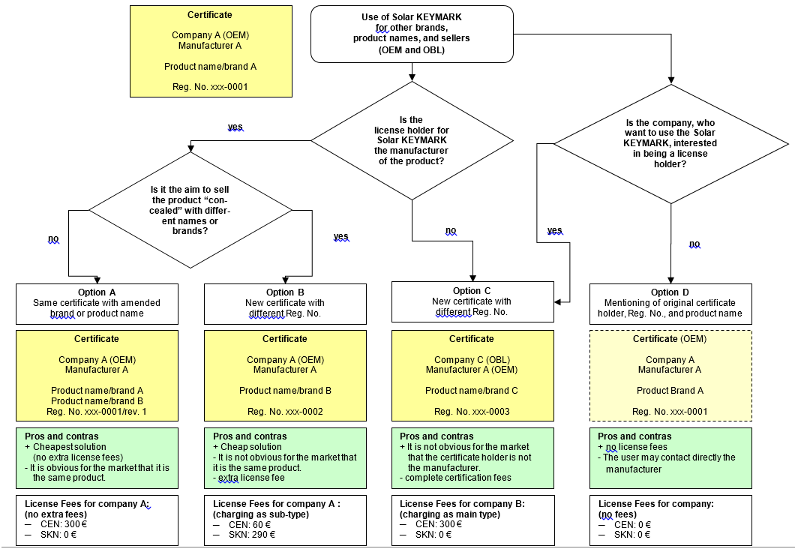
Figure 1: Flow Chart for OEM/OBL certifications
- All certification bodies are responsible for having available the information regarding their issued OEM and OBL certificates.
- If the products(s) listed on the SK data sheet cannot be correlated unambiguously with the products mentioned in the test reports, the correlation must be known and documented by the CB that issued the certificates.

Granting SOLAR KEYMARK certificates (option A, B, and C)

Rules and requirements
- OBL certificates have to be issued always on the basis of OEM certificates. It is not possible to issue an OBL certificate on the basis of another OBL certificate.
- For every new certificate (OEM or OBL) a new registration No. is required.
- Data sheets for OBL certificates shall always be in the current valid Excel-format to harmonize the European database for solar thermal products.
- The data sheet of the respective OEM certificate shall be based on the latest version of ScenoCalc (the corresponding OEM datasheet can but must not be updated).
- The OBL certificate can have either 5-year validity or the same expiry date as the main certificate. This is finally in the responsibility of the CB. In any case, the OBL certificate needs to be linked to the OEM certificate (e.g. concerning surveillance procedures like factory inspection and/or physical inspection).

Documents needed
- Application form provided by the CB who issued the OEM certificate taking into account the relationship between OEM and OBL manufacturer and the respective obligations (e.g. changing the product, selling different products with the same product name/brand etc.)
- Written permission for the applicant for the right to use the original test report(s) and inspection report for the products for which the OBL manufacturer applies for certification.
- Declaration of OEM and OBL that the respective product is the same as the certified once
- Test report/check on new installation manual and type plate for the applied products and referring to the original rest report. In case of families, the manuals and type plates of all family members need to be checked as well (but not for intermediate sizes not yet produced or customized collectors in modular sizes/grid).
- Remark: If the OBL customer wants to have a complete test report, the testing laboratory can issue this without referring to accreditation.
- New data sheet issued for the OBL referring to the second test report of the documents check (some certification bodies will prepare this as part of the certificate)
- In some cases the CB requires a registration of the trade mark/brand/company
- Issuing a new SK certificate based on the second test report

Fees
- Certification fee according to the current schedule of fees of the involved CB
- License fee to CEN and SKN according to Annex C of the Scheme Rules (every new certificate – also for brands/trademarks – includes a license fee to CEN and/or SKN)
- This ensures a transparent and fair competition between the CB for charging license CEN/SKN fees. Otherwise, the certificate holder may move to another CB because of reduced license fees.

Maintaining SOLAR KEYMARK certificates (option A, B, and C)
Requirements for follow-up activities
- Bi-annual Physical Inspection (PI) carried out at the manufacturer, check of the installation manual, and type plate of the sub-license holder at the OBL or OEM.
- A Yearly Factory Inspection (FI) at the sub-license holder is currently not requested but possible for special reasons.
As long as the surveillance requirements were assessed positive, the sub-license can be renewed for further 5 years.
The method of remote factory inspection is applicable for interim and follow up inspections under the following conditions:
- Within the period of validity of a certificate (5 years), maximum two remote inspections might be performed.
- Two serial remote inspections are not allowed.
- The use of the method remote inspection as well as the performing inspector has to be confirmed by the CB individually and in advance.
- If former inspections had shown serious non conformities, the CB should deny the use of remote inspection method.
- Initial inspections are excluded from remote inspection method.
This method is preliminary accepted for two years and will be evaluated in autumn meeting 2021 after discussion of gained experiences.

Rules for withdrawal of certificates
It is possible to withdraw an OBL certificate if the OEM certificate holder does not want to cooperate with the OBL manufacturer anymore. In this case there is no contract (commercial relationship) anymore between both companies. The Keymark certified products on stock can be sold for a certain period with confirmation of the CB (maxi-mum limit should be 2 years).
If the product is no longer being produced, the certificate will be withdrawn.
If the product is still being produced, the OBL certificate is handled like OEM certifi-cate and can remain valid as long as all requirements of the respective standard(s) and Scheme Rules (e.g. the surveillance requirements) are fulfilled.

The SOLAR KEYMARK complaint procedure
All complaints against bodies engaged in certification, testing and inspection and against any kind of misuse of the SK shall be treated following the procedures defined in in this chapter. Throughout the entire procedure, the confidentiality must be kept by all parties involved.

General procedure
Whether there is a complaint about a test, test report or data sheet that affects a testing laboratory, about an inspection or inspection report that affects an inspection body, about the use of the Keymark that affects a license holder, about any action of a CB, or any other issue that affects a Keymark certified product, the complaint has to be addressed directly to the party in question. Each party has a quality system and shall apply it to answer the complainant.
The entity that has the highest responsibility in this part of the complaint is the CB. The CB shall always be informed in due time about a complaint with regard to one of its license holders or subcontracted bodies.
If the complainant is not satisfied with the answer and the actions of the party in question, it should raise the complaint to the responsible CB. If the CB gives an answer that does not satisfy the complainant, the complainant shall react within 1 month, then it may go on to the first escalation step.
There are three escalation steps:
- If the answer of the member of the SKN does not satisfy the complainant, it may send an appeal to the next higher level, which is the Head of CB working group
- If the answer of the Head of CB WG does not satisfy the complainant, it may send an appeal to the KMO.
- If the answer of the KMO does not satisfy the complainant, it may send a new and last appeal to CEN-CENELEC.
Step 1: Appeal to the Head of CB WG
If the complainant is not satisfied with the answer of the party in question it may send an appeal to the Head of CB WG. There must be a copy of this appeal sent to the CB that issued the certificate related to the complaint, the Chairman and the Manager of SKN. The following steps shall take place:
- The Head of CB WG will acknowledge receipt of the complaint to the complainant within one week.
- The Head of CB WG will begin an investigation together with the complaint committee (Chairman and manager of SKN, one representative of a testing laboratory and one representative of ESTIF/SHE). Each group that is represented (CB, TL, industry) shall choose their representative and a substitute. In case that any member of the complaint committee is involved and not able to show impartiality, the substitute shall be used.
- The maximum time allowed for sending an answer to the complainant is a period of one month. This answer must offer either the result of the investigation or the first phase of the investigation, with a clear action plan to finish it. In case of a retest, the complaint committee will determine the maximum time for testing (max 6 months).
- To facilitate the investigation the Head of CB WG may use a third party team and/or a special test according to §8.3 of the SK Scheme Rules.
- After the investigation, the Head of CB WG will send his recommendation to the party in question.
- After receiving the recommendation from the Head of CB WG, the party in question will make a decision within two weeks. The party in question has to inform the CB of his actions. Based on these actions the CB must take action with regard to the certificate. These actions may involve modifications, suspension or withdrawal of the certificate.
- The CB will then inform the Head of CB WG and the complainant of any actions taken.
- The complainant must respond to the decision whether it is satisfied or not with the answer specifying the reasons. Not responding within one month implies satisfaction with the answer.
- The Head of CB WG has to create a file containing all documentation of the complaint.
- The Manager and Chairman will present the complaint including the recommendation from the head of CB WG and the steps taken (keeping confidentiality) at the next SKN meeting.
If the complainant is not satisfied with the answer and the actions of the party in question and the CB, he may then go on to the second step.
Step 2: Appeal to KMO
If the complainant is not satisfied with the answer of the Head of CB WG it may send an appeal to the KMO.
There must be a copy of this appeal to the CB, and to the head of CB WG.
The Head of CB WG then shall send the file, informed by the Complaint committee containing all information from the previous investigation to the KMO. The KMO will then start an investigation following its own procedure (according to 7.4.2 of CIR4). If the complainant is not satisfied with the answer and the actions of the KMO, it may then go on to the third step.
Step 3: Appeal to CEN-CENELEC
If the complainant is not satisfied with the answer of the KMO, it may send an appeal to CEN-CENELEC. There must be a copy of this appeal to the CB, KMO, Chairman and Manager of SKN. CEN will then start an investigation following its own procedure (according to 7.4.3 of CIR4) and make a final decision on the complaint.
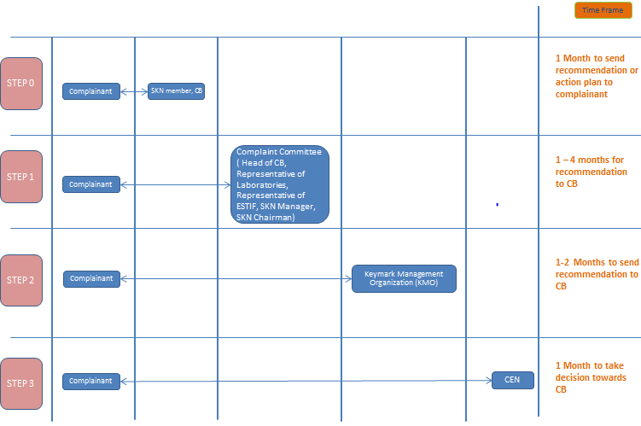
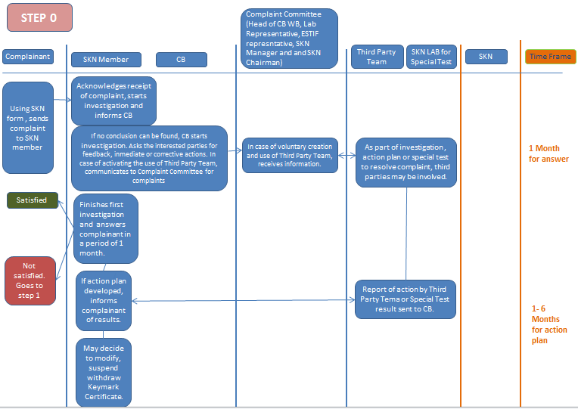

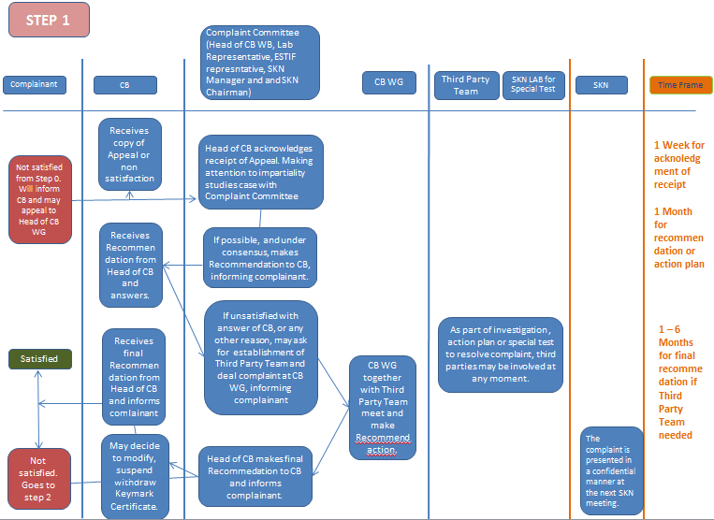
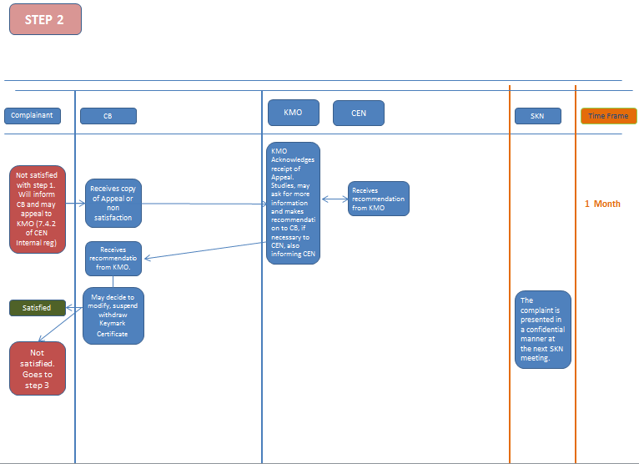

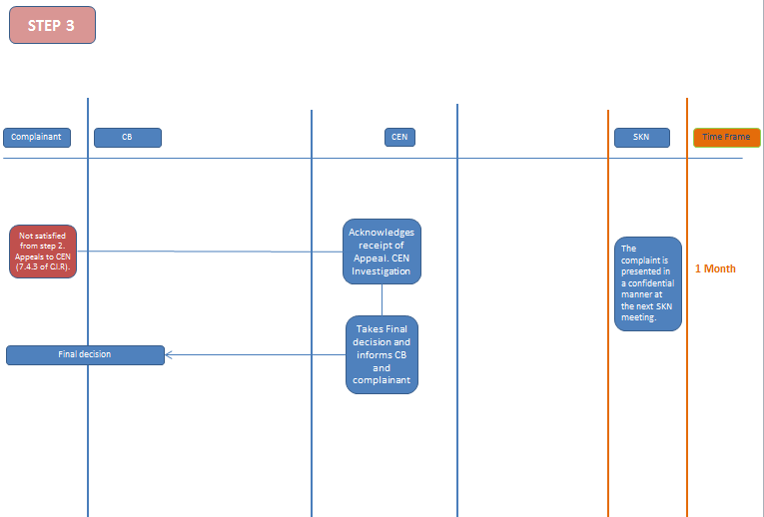

Third party team
A third party team can be involved at any time in a special test or any reassessment that is done in the process of a complaint under consensus by all the parties. This third party team will be considered as any WG established during an SKNM and is considered under the same working and funding conditions.
A third party team of experts may be established for assessment of tests, to act as a third party auditor during the testing procedure and preparation of a final report on technical issues regarding both tests. It will normally have one leader and two additional members as necessary, but it may be also a one member team or consist of more than three. The members may be chosen from a list of volunteers from SKN members that can prove their impartiality (that is they are not involved in the complaint; do not have any relationship with the complainants or those that are complained about). Each eligible member must have at least 7 years of experience in their current position. If the third party team sees the need to include a non-member this has to be confirmed by the complaint committee.
The third party team shall be chosen by consensus between all parties involved from a pool presented by the complaint committee. In case there is no consensus, then each party may choose one member. All the members will sign a confidentiality agreement on the following work to be done.
After the respective action taken, a report is prepared by the third party team. This report is presented to the involved parties in a confidential manner. The report explains any technical anomalies or differences found during the tests taken. The conclusions of the report can be:
- Recommendations to CEN/TC 312 regarding inconsistency in testing methods
- Communication of discrepancy to one or both of the labs regarding testing method or interpretation of results
- Recommendations to the CB for decision to take regarding the data sheet to adopt as annex to the certificate (in case of anomalies in testing procedures)
- Any other recommendations
This team can also be used by all members of the SKN in case of a complaint regarding the SK. All requests have to be made in writing to the complaint committee.

Special test
Complaints concerning the conformity of a certified product are handled according to CIR4 section 10.5 (Complaints) and 7.4 (Appeal procedure). In this connection a special test can be ordered through the CB by anyone, if the fulfilment of the requirements of the certification program or the registered values of a certified product is doubted.
The special test is normally to be made as a type test and in agreement with the manufacturer by a second approved SK testing laboratory. If only one or a few points of the certification program are challenged, the CB decides after consulting the TL if the special test can be made as a partial or supplementary test.
If the tested product does not fulfil the requirements and/or does not comply with the registered values, the legal person holding the Keymark licence of the product in question has to carry the costs of the special test.
If the tested product fulfils the requirements and complies with the registered values, the costs have to be carried by the party which questioned the fulfilment of the requirements or registered values and ordered the test through the CB.
If the special test shows that the failure of the product to conform to the requirements and/or registered values is due to random manufacturing error or transport damage, the testing laboratory has to take a second sample. The result of this test is the obliging result for the special test.
The legal person holding the Keymark license or a person authorised by the legal person holding the Keymark licence must have the opportunity to take part during the whole procedure of the special test. He must be informed of the results of the test without delay to have the chance to react directly.
If the special test states deviations from the requirements and/or the registered values, the CB requires the legal person holding the Keymark license to rectify the faults within a certain limited time which should not exceed one month, depending on the extent and manner of the fabrication. Thereafter the testing laboratory performs a new special test, the extent and manner being determined by the CB consulting the testing laboratory.
Compliance with the registered values is confirmed if the compliance criteria defined in the corresponding PSA Clause 3 are fulfilled.

Requirements and obligations for CBs, TLs and IBs
The general requirements are given in Chapter 9 of part B of the CIR4.
The additional requirements/rules in this specific scheme are the following:
- All CBs, TLs and IBs shall participate actively in the SKN as laid down in the SK Internal Regulations.
- The TLs shall be accredited in accordance with ISO 17025 for the standards listed in 2.1 for which the TL provides testing services.
- The TL must be recognized by at least one SK CB.
- The CBs shall collect a fee (see Chapter 6) for each valid license to be transferred to the secretariat of the SKN.
- IBs shall have sufficient expertise in solar thermal technology. It is under the responsibility of the CB to recognize and employ inspectors.
- CBs and TLs shall be listed together with their accreditation certificates on the SKN webpage. TLs and independent IBs shall be listed on the SKN webpage mentioning the recognizing CB.
- In case of doubts about the interpretation of the Scheme Rules and the standards or if CBs/TLs/IBs step over other unclear situations related with the SK certification, the CBs/TLs/IBs shall get advice from other CBs/TLs/IBs as appropriate. The CBs/TLs/IBs shall then bring their decisions and solutions into the SKN to improve the SK working rules and to make sure that all work according to the same procedures.

Legal

European regulations
The SK is not replacing legal requirements set up by the EU such as CE, PED, MD etc. It is under the sole responsibility of the manufacturer to fulfil the regulations and directives.

EU-GDPR
The contact details of all CBs, TLs and IBs involved in the SKN are published on the SKN Website. It is in their own responsibility to indicate contact details which are not in conflict with the EU General Data Protection Regulation (EU-GDPR).
All SK datasheets are published on the SK webpage. The datasheets may include contact details such as emails and phone numbers. It is under the responsibility of the certificate holder to indicate contact details, which are not in conflict with the EU-GDPR.
All members of the SKN can be listed on the SK webpage with contact details. It is under the responsibility of the SKN member to indicate contact details, which are not in conflict with the EU-GDPR. Anonymous SKN membership is not possible.
The SKN management may send important information to all certificate holders (via the CBs) and to all members of the SKN.
Under no circumstances any contact details which are not published on the SKN webpage anyway are forwarded to any other organization.
By participating in the SKN and/or by applying for a SKN certificate the rules defined in this chapter are accepted. It is in the responsibility of the CBs to inform applicants accordingly.

Annexes, Forms and Templates
The following Annexes are integral part of the SK Scheme Rules
Annex A Inspection report templates
A1 Factory inspection report
A2 Physical inspection report
Annex E FPC
Annex P Product Specific Annex: Collectors EN 12975
P1 General
P2 Technical documentation
P3 Correction and interpretation file for the standard
P4.1 Datasheet Scenocalc
P4.2 Datasheet Aircow
P4.2 Manual AirCow
P5.1 PVT
P5.2 Coloured Glass
P5.3 Exchange rules for insulation
P5.4 Hydraulic Designation Code
P5.5 In-Situ Collector Certification
P5.6 Calculation Kd ISO 9806
Annex Q Product Specific Annex: Systems EN 12976
Q1 General
Q2 Technical Documentation
Q3 Correction File
Q4 Datasheet
Annex R Product Specific Annex: Systems EN 12977
R1 General
R2 Technical Documentation
R3 Correction File
R4.1 Datasheet Store
R4.2 Datasheet Controller
R5.1 Application of the SolTherm software for EN 12977-2 system simulations
Annex W Weather Database
W1 CEN Locations
W2 EC Locations
W3 Other Locations

PQR are annexes where the content should be transferred to ISO/CE/IEC standards if possible. Ideal case: PQR are empty annexes.

ftp://ftp.cen.eu/BOSS/Reference_Documents/IR/CEN_CLC/IR4_E.pdf

