Heating up Europe

The energy transition is one of the hot topics in European political debate, but the main debate seems to be focused only on electricity. Even though 47% of the final energy demand is represented by heating and cooling, compared to a 28% for transport and only 25% for electricity.

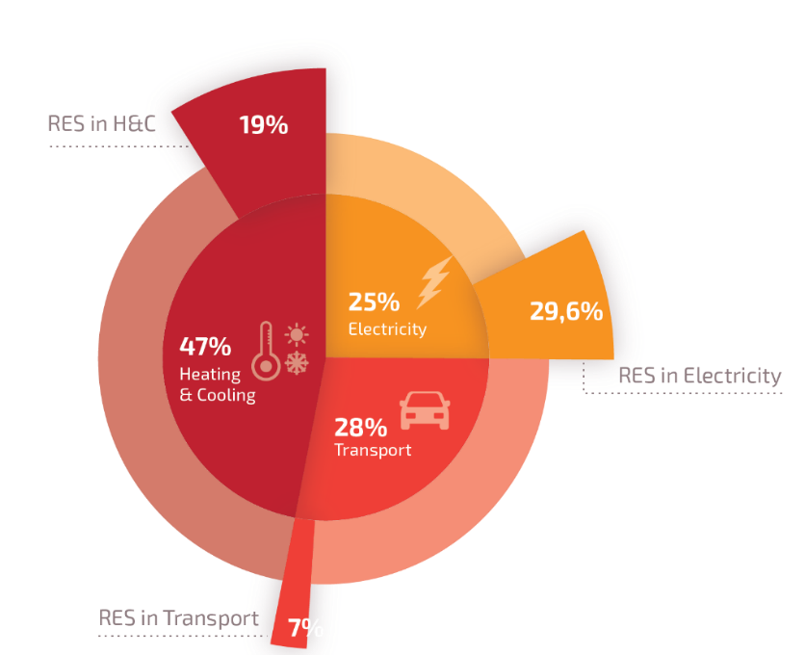

Energy consumption in Europe, data extracted from Renewable Heating and Cooling European Technology and Innovation Platform (RHC-ETIP)

Looking at future trends, like the increase of electric vehicles, this percentages are likely to change but what still remains clear is that the decarbonisation of our energy system won’t make it without a full decarbonisation of the heating and cooling sector. Nowadays, only 19% of this sector is based on renewables, and there are already several technologies as solar thermal, providing direct renewable heat in a cost-effective way, which shows huge potentials for further deployment.

Benefits of solar thermal

Solar thermal is a technology with multiple benefits. In brief, it produces direct renewable heat without producing any CO₂ emission. The most common use for this renewable heat is the supply of hot water or space heating in the residential sector. Nevertheless, it can be used for different purposes and applications, including district heating or industrial process heat.

Going beyond the environmental aspects and the fact that solar heat is among the renewable solutions with the best performance in terms of carbon footprint, solar heating has also economic advantages, creating local jobs and replacing imports of fossil fuels. Solar heating systems already includes thermal storage capacity, which in some cases can be even seasonal. Additionally, it can be combined with other technologies, solutions. These different aspects make it a no regret option in the current and future energy mix.

For example, a single domestic solar thermal system in Greece can save up to 1.5 tons of CO2 per year, which is the equivalent of the emissions produced by one car in Europe every year. Furthermore, the components of a solar thermal system are almost 100% recyclable or reusable, contributing to its low carbon footprint.

How does solar thermal work?

The functioning of a solar thermal system is quite simple: solar radiation is collected and converted into heat in the collector absorber, the thermal energy is then transferred through a heat exchanger to a thermal storage unit and be used for different applications: heating up the water of a swimming pool, allowing you to take a warm shower even during the night, making your home warm and comfortable or enabling industrial process up to 150°C.

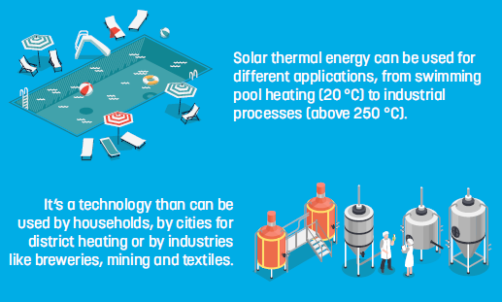
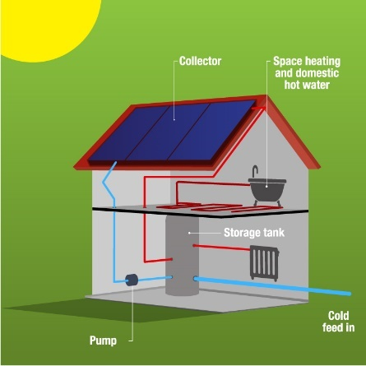

Find more explanatory factsheets about solar thermal applications

Compatible with other energy systems /Fostering system integration

Despite being highly sustainable, solar systems present another big advantage: they are easily compatible with renewable and fossil technologies, both in the heating and the electricity sector.

For instance, coupling a solar collector with a heat pump will make the efficiency of the heat pump higher: using solar heat as main source, and the heat pump as a backup for example in the winter season will make the lifetime of the heat pump longer, and the overall system more energy efficient.
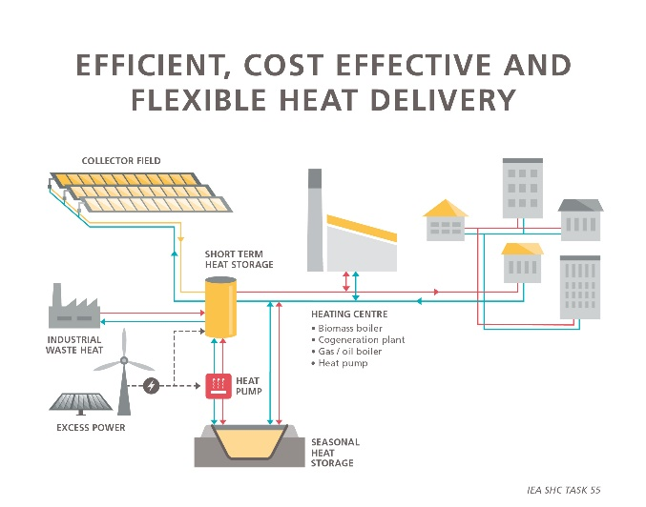
Another smart application would be to couple a solar collector with an existing gas boiler (which may be still properly working) in order to reduce the consumption of the boiler and hence its emissions. When the need to replace the boiler arises, the solar thermal system can be kept and combined, for instance, with a biomass stove or other green solutions, making it a 100% renewable system. Adding solar thermal to your energy system will always lead to a direct reduction of primary energy consumption and lower lifecycle costs.

Source: International Energy Agency Solar Heating and Cooling
Technology Collaboration Programme, IEA SHC Task55

Thermal storage solves flexibility and integration

As mentioned before, solar heat is also compatible with electrical solutions, such as solar photovoltaic. It’s important to note that solar thermal systems always include a thermal storage unit as built-in feature to cope with daily and, in some cases, seasonal variations.
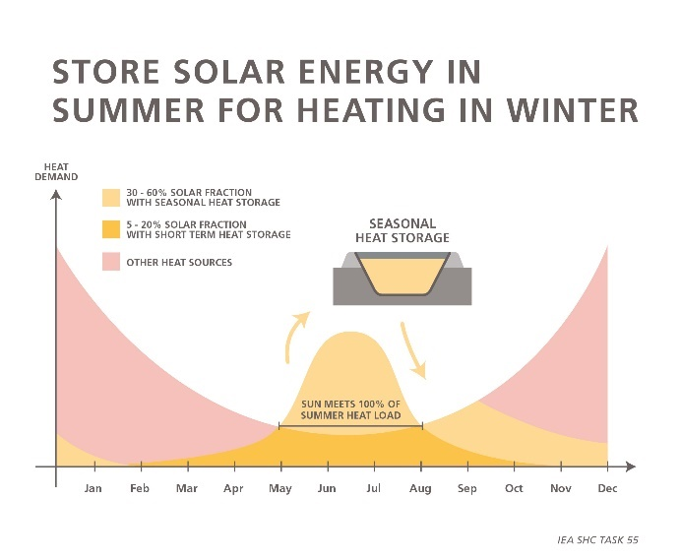
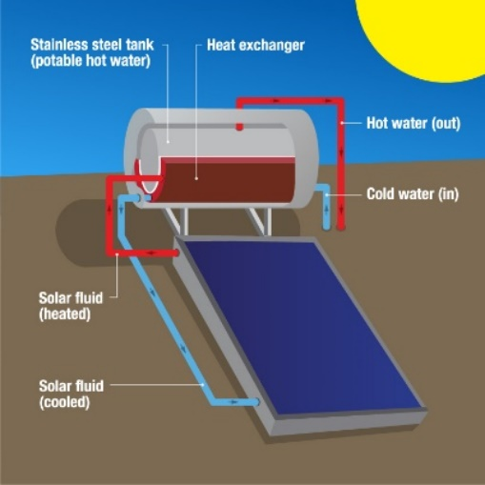

Source: Solar Heat Europe publications Source: IEA SHC Task55

Therefore, thermal storage can play a key role in reducing peak demand in the electricity grid and compensating energy fluctuations. Thermal storage also acts as a technology enabler which allows a further integration and can facilitate sector coupling.

Not just for Southern countries: the success story in Denmark

When thinking about solar thermal it is common to fall into the preconceived idea that renewable energy is just for “warm countries”. But actually, one of the best examples in the European market is Denmark, where solar thermal systems connected to district heating networks and using a seasonal storage can provide solar heat at a cost below 3cent/KWh.
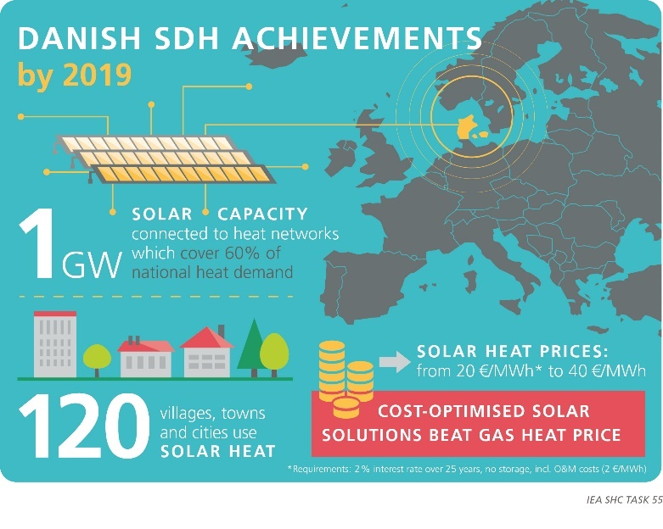
Similar costs can be reached also by solar water heaters in Southern Europe. On the other hand, the heat generation via a gas boiler costs between 28-35EUR/MWh and the gas prices are likely to increase in the future, whilst solar energy is not.
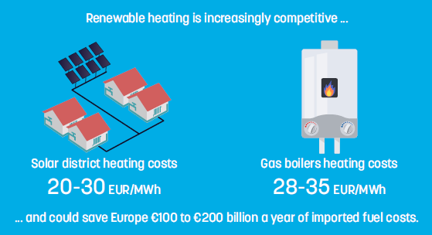

Source Solar Heat Europe Manifesto

Source: IEA SHC Task55

Not just for buildings

This technology is also extremely scalable, ranging from decentralised domestic systems, with a 2-kW capacity, to large scale plants in the MW_{th} range. Applications in buildings involve both residential and commercial uses, but the most promising ones are solar-assisted district heating (SDH) and solar heat for industrial processes (SHIP), which are particularly developed in Central and Northern Europe.
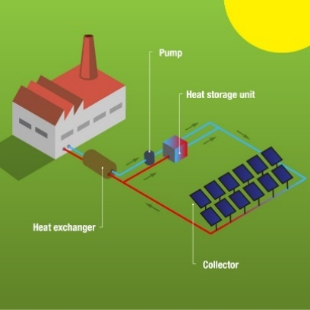
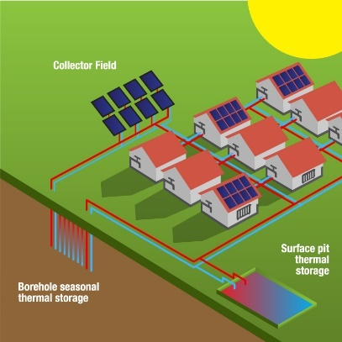

Solar heat for district heating and industrial processes
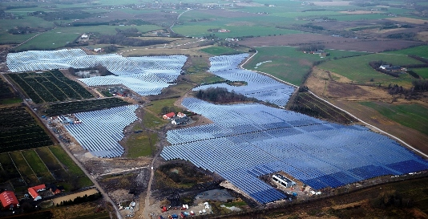

Solar District Heating in Silkeborg, Denmark (Arcon-Sunmark)

A European technology and a net exporter sector

Every year, around 2GW of solar heat are installed in Europe meaning a 2 billion euros turnover based mainly on local manufacturing and local jobs. Germany alone exported 5.2 billion euros worth of products and components between 2000 to 2015, and Greece manufacturers export over 60% of their production annually.

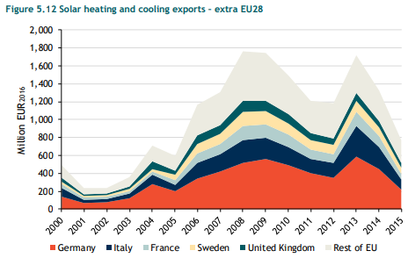

Data extracted from Solar Heat WorldWide 2019, p.42 and Trinomics: “Impacts of EU actions supporting the development of renewable energy technologies” page 47 : Germany is leading the exports – exporting EUR 5 232 million worth of components,
over the period 2000 to 2015)

Overall, China dominates the global market but in Europe the situation is different: given the European high-quality standards, approximately 90% of products in the EU market are of European origin making this sector a net exporter to South America, Africa and China, among others. This is a key factor for the European industrial leadership while ensuring the security of our energy supplies. Overall the market is showing positive trends and growing in Denmark, Poland and Southern Europe.
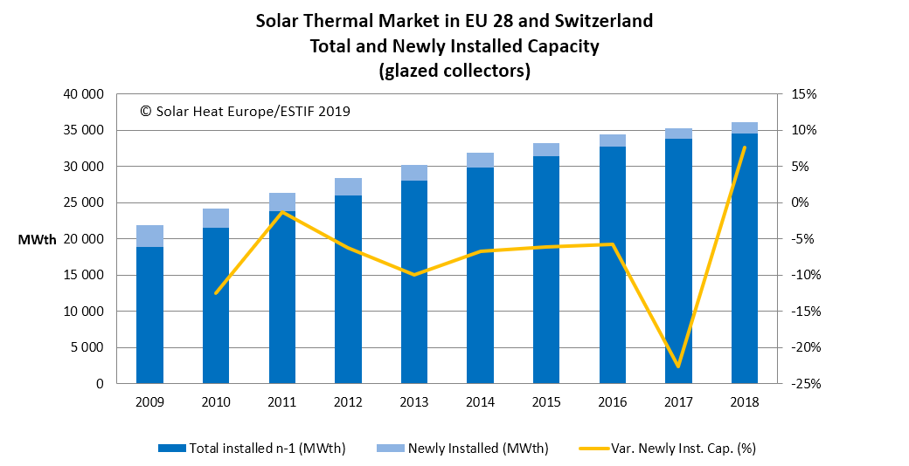

Solar Heat Europe report on Solar Heat Markets in 2018

2030 as a milestone

A major contribution to energy transition will be people’s embracement of green solutions and change in consumption behaviour. Heating systems have an average lifetime of 15-20, therefore all fossil-based systems installed in 2030 are likely to be still active (and polluting) in 2050. Member States must make citizens aware of the existing alternatives, in order to choose renewable options instead of polluting ones.

Planned replacement of heating systems

Usually consumers change their systems when these break down. And the systems are more likely to breakdown during winter, when their use is more intensive. This situation creates an “emergency”, requiring an urgent replacement. The time constraints limit seriously the options and, in most cases, consumers maintain a similar system to the one they had before, generally using fossil fuels.

Renewable heating and cooling solutions are expected to take a prominent role in achieving a 2050 decarbonised systems. That’s why public authorities should promote the planned replacement of heating systems and allow citizens to choose in advance among the best renewable options.
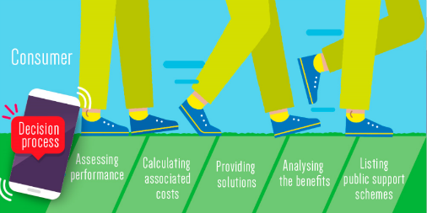

HARP stands for Heating Appliances Retrofit Planning. It is a project funded by the European Union through the Horizon 2020 framework. HARP will develop an application providing consumers with an indicative assessment of the performance and costs of their installed heating system and accompany them in the replacement process, informing about efficient alternatives, benefits and support schemes.

And what’s next? / Next steps

The European Green Deal or the New Pact for Climate announced by the president-elect of the European Commission, Ursula von der Leyen are examples of the strong commitment of Europe towards renewables and climate change, because finally it is seen as an emergency.

A silent revolution is happening in Europe in the search of solutions for our climate challenge. While heating is half of the energy problem, renewable heat and solar heat are part of the solution.

