26th Solar Keymark Network meeting  Initial draft agenda (R0)_2019-01-07 Mailing date_ VD/AB  Meeting time:  Tuesday, March 5th, 2019, 13:00 - 18:00  Wednesday, March 6th, 2019, 09:00 - 13:00  Meeting location:  RISE- Research Institutes of Sweden (auditorium)  Drottning Kristinas väg 61, Stockholm, Sweden  RISE contact: Mrs Charlotte Ehn,  charlotte.ehn@ri.se, +46 10 516 53 41, +46 10 516 50 00 (vxl)  See also doc: "SKN26 _Information for Stockholm meeting place "  Recommended hotels: " SKN26 Information about Hotels for Stockholm meeting"  Deadline for proposals for decisions and resolutions or any item to be added in the agenda: February 12th, 2019  Web conference login - to come | 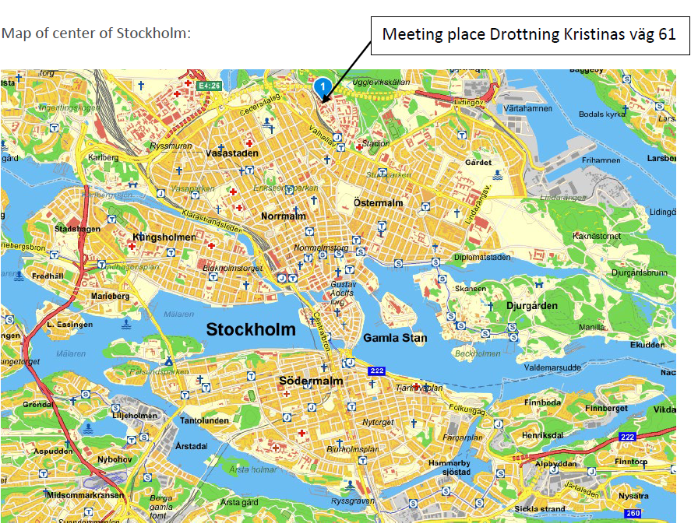
Related meetings at same place (see overview/time schedule of meetings below agenda):
- CEN/TC312 WG1 "Solar Collectors"
- CEN/TC312 WG2 "Factory made systems"
- CEN TC312 "Thermal solar systems and components"
- Global Solar certification Network, GSCN
- IEA SHC Task 57 “Solar Standards and Certification”
On-line registration - here - Registration deadline: February 16th, 2019
Note: If the above on-line registration form does not work for you, please e-mail to Vassiliki Drosou at drosou@cres.gr

Tuesday, March 5th, 13:00
Item | Decision/-resolution  requested | Time | Topic/content/responsible | Related documents /comments/details
 |  |  | Opening of the meeting /AB  Short welcome and some practical information  Check preconditions for voting:  - At least 3 industrial representatives ?  - >50 % obligatory members (so 19 out of 36) ? | SKN_N0426R0_NonCompetition.pdf
Introduction of participants /All
Excuses from:
Attending via web:
 |  |  | Approval of the agenda /All
 |  |  | Comments to the minutes of the 25th SKN meeting /AB
 |  |  | Review of Decision list /VD
Dates and places of next meeting(s) /AB/VD
- 27th meeting: 2019 - October 22nd, 09:00 - 12:00 and October 23rd, 09:00 - 12:00. Web Meeting
- 28th meeting: 2020 - March 10th, 13:00-18:00 and March 11th 09:00-13:00, Athens, Greece (hosted by EBHE)
- 29th meeting: 2020 - October 20th, 09:00 - 12:00 and October 21st , 09:00 - 12:00. Web Meeting
- 30th meeting: 2021 - March 9th, 13:00-18:00 and March 10th, 09:00 - 13:00 – Physical meeting HOSTED By?
 |  |  | Proposal for decision / SCF steering group for SCF project applications (10th call) / H. Drück  Funding of proposals from the 10th SCF call  The proposals recommend by the Solar Certification Fund Steering Group for funding as described in document SKN_N02xxR0 are accepted and the corresponding activities will be funded. | Documents to come
 |  |  | Proposals for decisions and resolutions from “EK-TSuB – Prüflaboratorien” / H. Drück | Documents to come
 |  |  | New Solar Keymark Scheme Rules (AB/VD) | Documents to come
 |  |  | Report on Update on 10 % Rules WG /S. Fischer | Documents to come
 |  |  | Thermodynamic collectors / Follow up on Decision M24.D8 /S. Scholz | Documents to come
 |  |  | Proposal “procedure for issuing collector test reports based on transferring of data from existing test reports” /S.Scholz | Documents to come
 |  |  | Proposal New Annex D | Documents to come
 |  |  | New Equivalent absorber coatings? | Documents to come
 |  |  | New Equivalent glazing? | Documents to come
 |  |  | New Equivalent insulation? | Documents to come
 |  |  | Report from SK Database WG on Database and IT infrastructure / G.v. Amerongen | Documents to come
 |  |  | Report/update on “Inter-laboratory Comparison - ILC on Data Analysis”, SCF7 Project / AB | Documents to come
 |  |  | Report Air Collectors WG / K. Kramer | Documents to come
 |  |  | Report from PVT WG / U. Fritzsche | Documents to come
 |  |  | Report from “Call for industry participation in the SKN / AB” | Documents to come
 |  |  | Report on SRCC/UL PVT Approach / Christos Nikolaidis | Documents to come
 |  |  | WG on “In-Situ Certification / S. Mehnert | Documents to come
 |  |  | Information from CEN Keymark Management Organization / K. Vehring | Documents to come
 |  |  | Update on complaints and Reports on misuse of Solar Keymark / S. Scholz | Documents to come
 |  |  | Report from CB Working group / S. Scholz | Documents to come
 |  |  | Update on Action Plan working groups:  AP1 Strategy WG (?)  AP2 Marketing and Communication /G. Cazenave  AP3 Installers WG (K. Vehring) – on hold  AP6 Legal Requirements (G. v Amerongen) | Documents to come
 |  |  | Solar Certification Fund Projects – General Status Reports / PD | Documents to come
 |  |  | Update on Global Solar Certification Network | Documents to come
 |  |  | Update on standardisation (if necessary)  - CEN TC 312 / ISO TC 180 (VD)  - CEN/TC 312/WG1 and ISO/TC 180/WG4 (AB)  - CEN/TC 312/WG2 (V. Sharma)  - CEN/TC 312/WG3 (?)  - Updates from Liaison officers:  - S.Fischer (IEC/TC117)  - K.Kramer(IEC/TC128)  - J-M. Suter (TC164)  - G.v.Amerongen(TC 228 and TC371)  - Status for accreditation certificates on web | Documents to come
 |  |  | Update on solar heating and cooling market /PD | Documents to come
 |  |  | Any other business
 |  |  | End of meeting / AB
Meeting duration
1st day: 13:00 – 18:00 = 5 hours; one coffee break of 30min effective meeting time 4,5 hours
2nd day: 09:00 – 13:00 = 4 hours; one coffee break of 30min effective meeting time 3,5 hours
4,5 + 3,5 hours = 8 hours = 480 minutes effective meeting time

AB: Andreas Bohren, SPF, Chairman Solar Keymark Network, Andreas.Bohren@spf.ch
VD: Vassiliki Drosou, CRES, Manager of Solar Keymark Network, drosou@cres.gr
PD: Pedro Dias, ESTIF Secretary General, Administrative Secretary of Solar Keymark Network, pedro.dias@estif.org

