Solar Heating and Cooling
Manifesto

A call for a just energy transition
in the heating and cooling sector

Draft for Consultation with Members

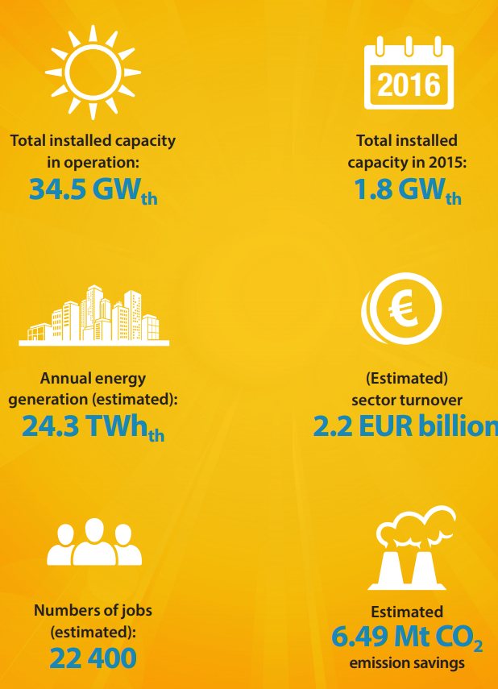

- The energy transition needs immediate action for Heating & Cooling

It is time to act, now! The heating sector represents almost half of the energy consumption in Europe and renewables account for only 18% of the total heating and cooling demand. Therefore, the energy transition in Europe needs renewable heat to play a core role.
Renewable heating provides benefits for local economies, allows for the creation of new jobs or job-reconversion, helps to improve air quality in cities and reduces greenhouse gas emissions.
“Renewable heating could save Europe €100 to €200 billion a year in terms of imported fuel costs”.
A new Multi-Financial Framework is a unique opportunity to drive the energy transition at the local level, mainly in the heating sector, by supporting investment schemes aiming to reconvert large or individual heating systems.
“The choice made by consumers regarding a new heating systems has a lock-in effect over the following two decades.”
The period from 2021-2027 will be critical to achieve the necessary energy transition. Heating systems have a lifetime in excess of 20 years, hence everything that is installed beyond 2030 will still be still there beyond 2050. The upcoming decade is therefore essential to consolidate new renewable and efficient solutions for the heating sector, to make the energy transition a reality and not just a vision.
- Heating & cooling is an enabler for local jobs and investments

Renewable heating brings clear and proven advantages for the local economies, replacing energy imports of fuels or electricity with clean energy produced locally, creating new business and jobs.
Furthermore, future energy systems need to be planned with a bottom-up approach, combining decentralised and centralised energy generation in a dispersed and effective energy network.
Municipalities will play a major role in designing a local energy system, assuming a stronger control over factors such as air quality, circular economy and energy as a local economic development factor.
European and national funds shall assist municipalities in driving the energy transition at local level, promoting the sustainable transition at local level, ensuring that adequate resources can overcome market barriers, such as the upfront investment costs both for public and private buildings and the need for skilled professionals available locally.
“50% of the investment in solar thermal systems is retained locally, in commercialisation, installation and maintenance activities.”

- Solar Heating & Cooling and thermal storage are no-regrets options
“Thermal storage is more than a solutions integrator, it is a policy and technology enabler”.
A clean, secure and cost-competitive energy system will involve a mix of different carbon-free sources, not relying on a few, centralised solutions, but rather on a canopy of different solutions. The heating market is twice the size of the electricity market, but the sector lacks attention and concrete actions from policy makers at the European, national and local levels.

- Solar thermal and other renewable heating options will play a key role in the energy transition. Solar heat is a proven technology which covers several applications, from 2kW solar water heaters in Southern Europe to 200 MW solar district heating systems in Central or Northern Europe.

- Solar thermal already today provides a large energy storage capacity, in the form of thermal storage. Currently there are over 10 million solar water storage systems installed in Europe, that can assist in integrating different solutions, from other renewable heating technologies (bioenergy, heat pumps).

- Furthermore, such technology can facilitate system integration, by providing storage capacity for power-to-heat solutions. In district heating systems there are today seasonal storage tanks, bringing energy management to a new dimension, beyond short term management.

- The thermal storage capacity therefore allows for the integration of different renewable solutions (heat or power), which can be connected to a thermal store. Hence is also facilitating policy developments, as new solutions can be integrated into the thermal storage while others can be phased-out more easily.

